**Software Engineering 2: Assignment –**

**CIRCLECOLORSLIDER**

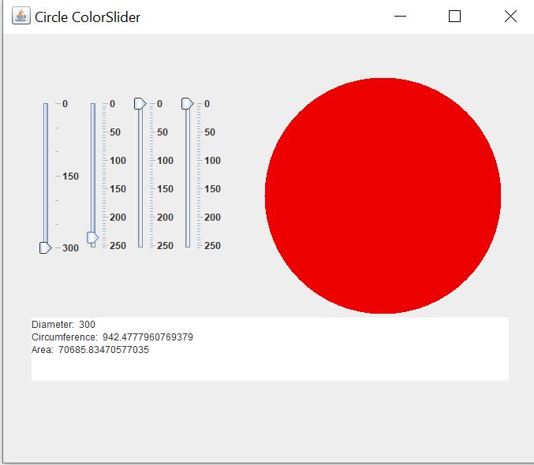CircleColorSlider Final Screenshots: 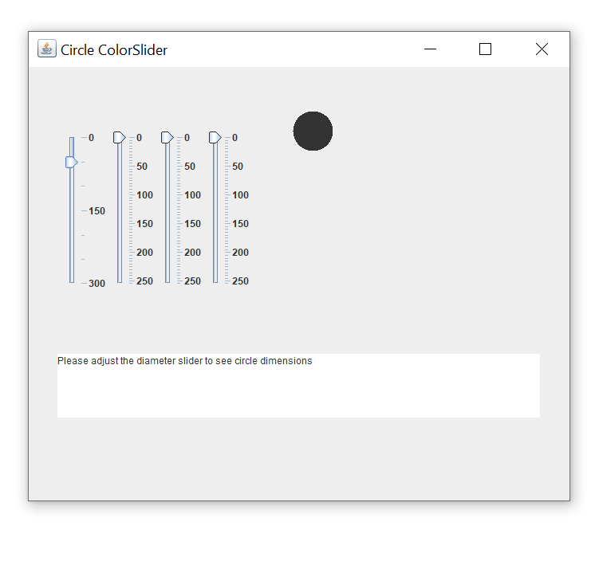

Red Slider

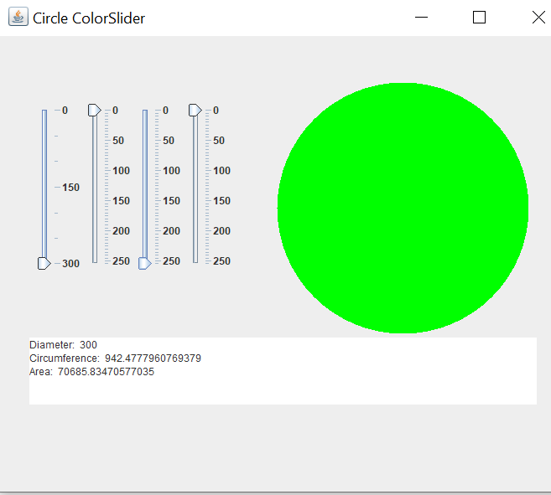 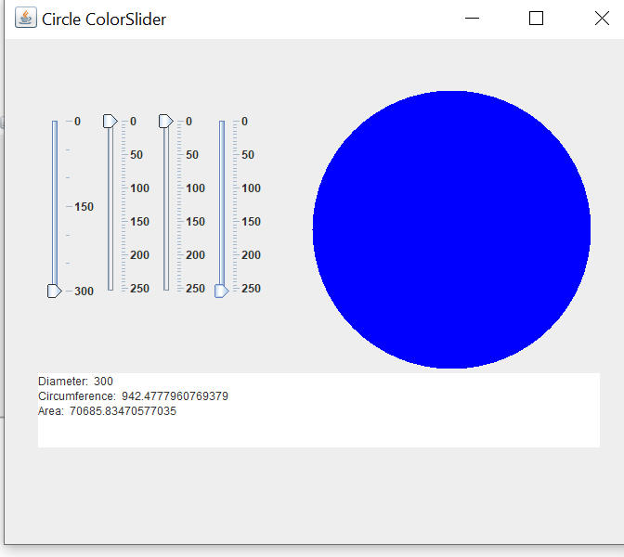

Green Slider Blue Slider

ScreenShots of the ColorCircleSlider Code:

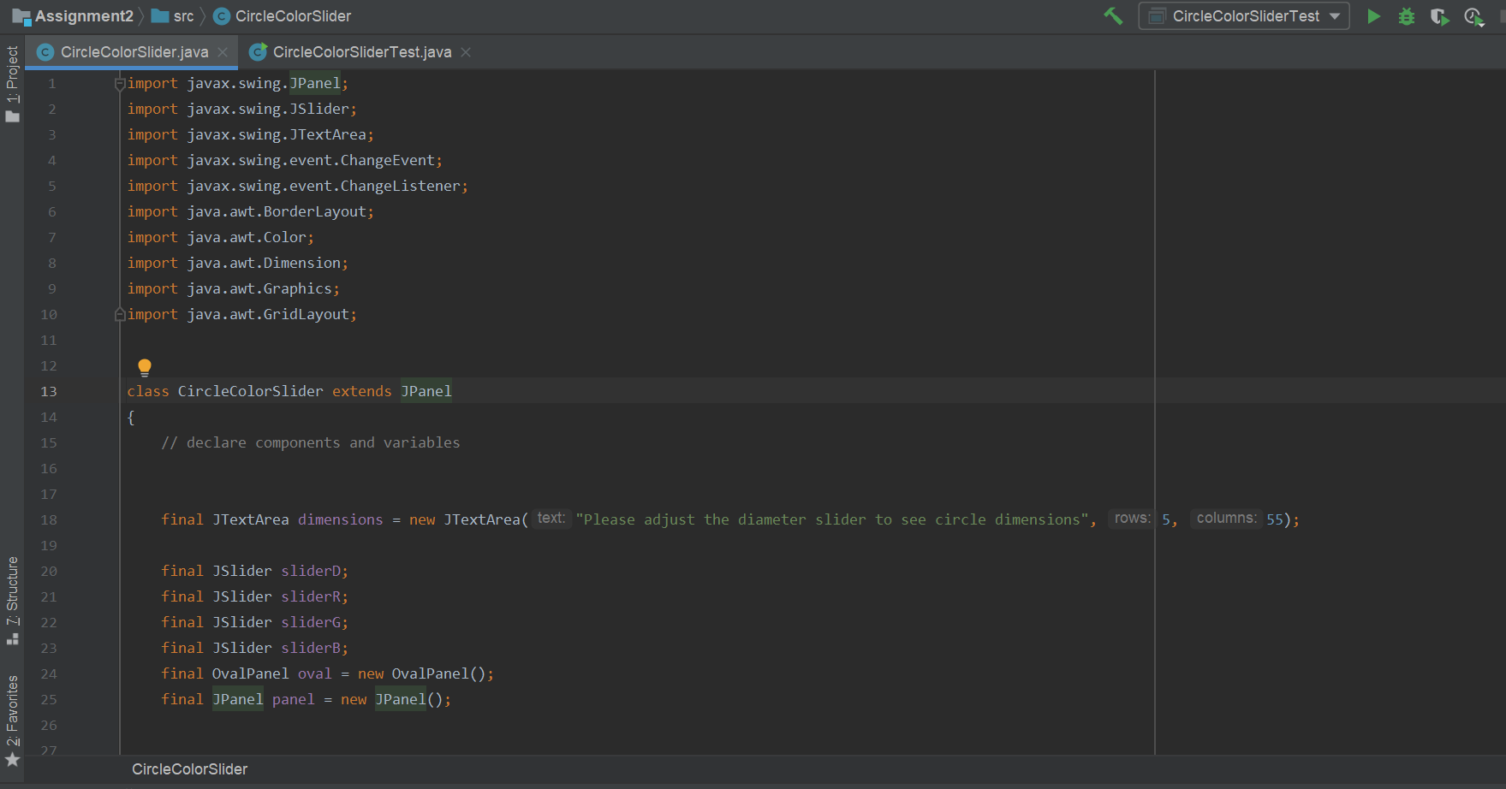

Fig:1 Imports all java API packges needed for the application.Class CircleColor extends JPanel to setup GUI and the main logic.Instantiate GUI components.

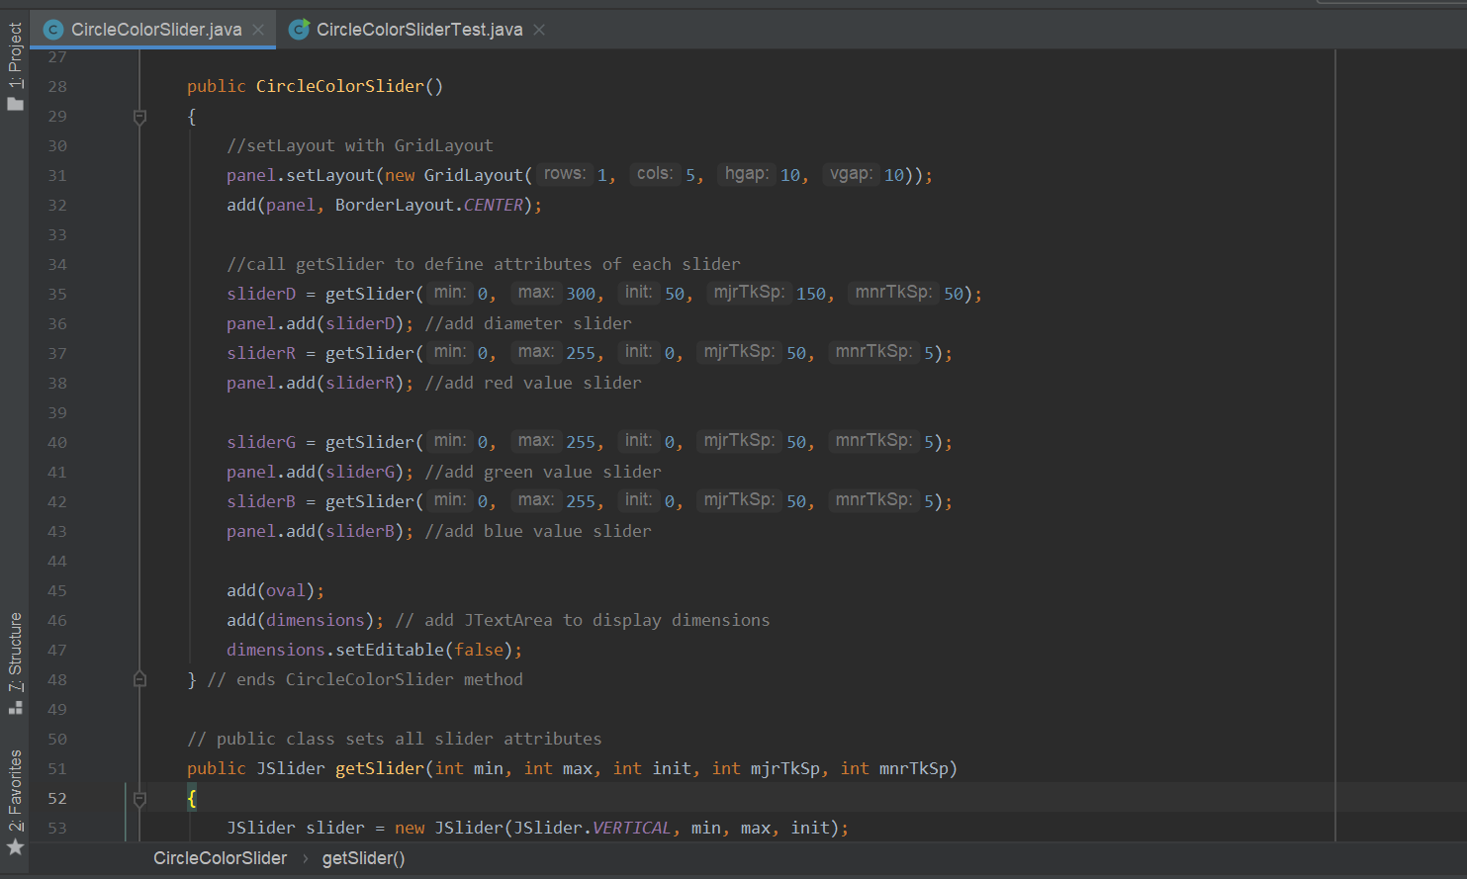

Fig 2: Constructor to setup GUI.layout is set with GridLayout

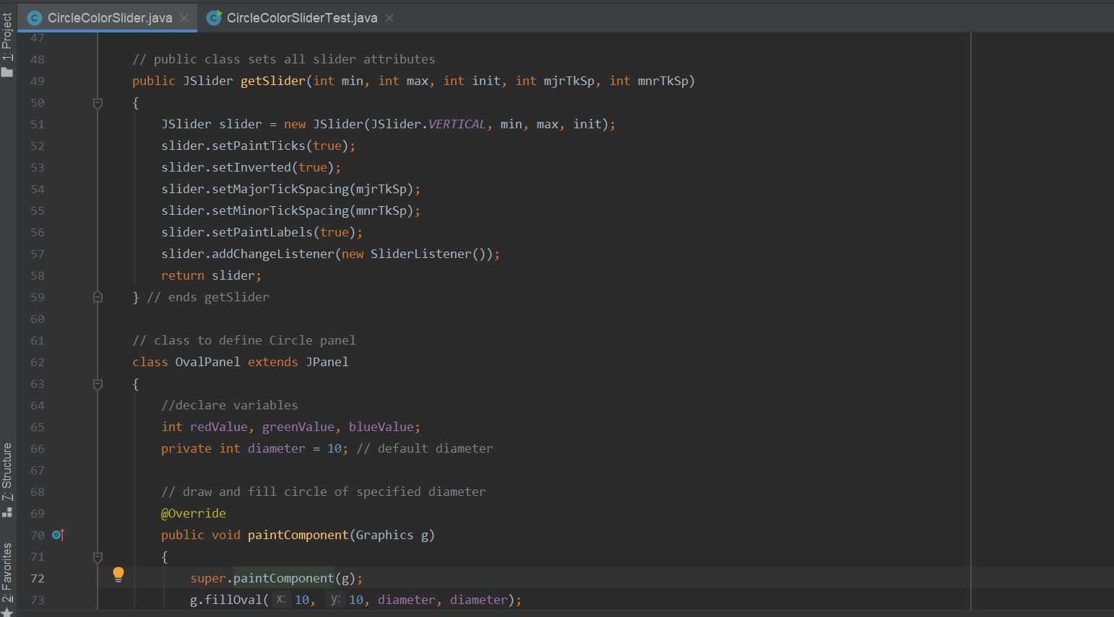

Fig 3&4 : JSliders are customized to display major tick marks and thumb that allows user to select a value.it also aligns the jslider components to vertical orientation.JSlider method SetInverted with Boolean argument true was used to reverse the min &max values on the sliders.Class OvalPanel contains a paintcomponent method that draws a filled oval,a setDiameter method that changes the circles diameter and repaints OvalPanel .

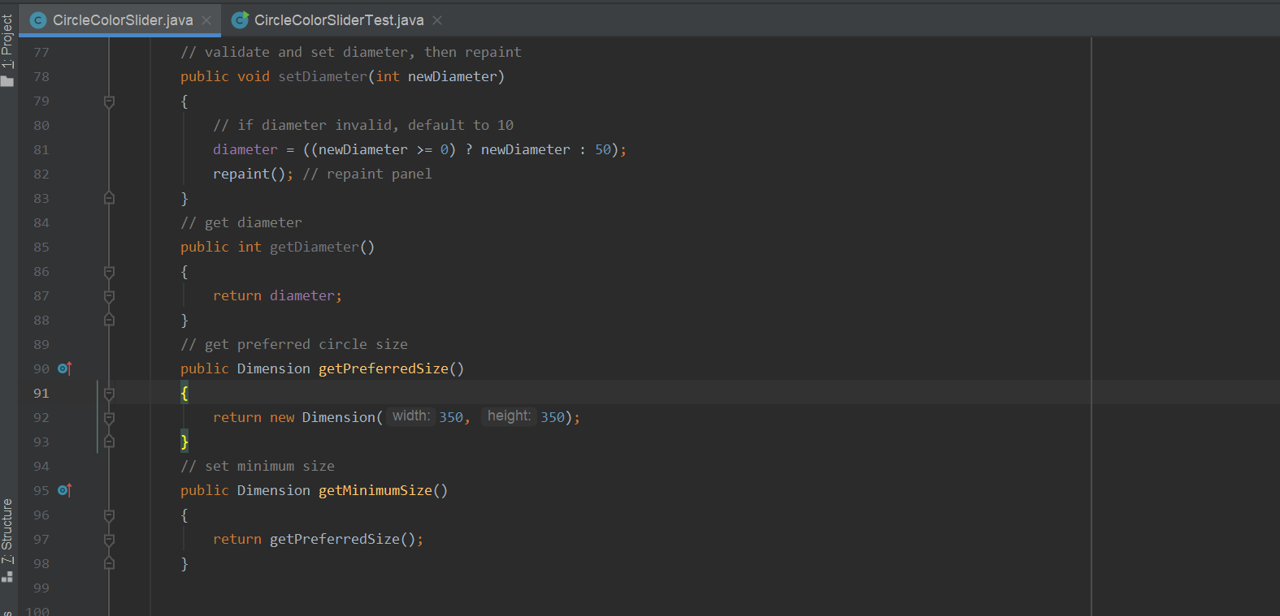

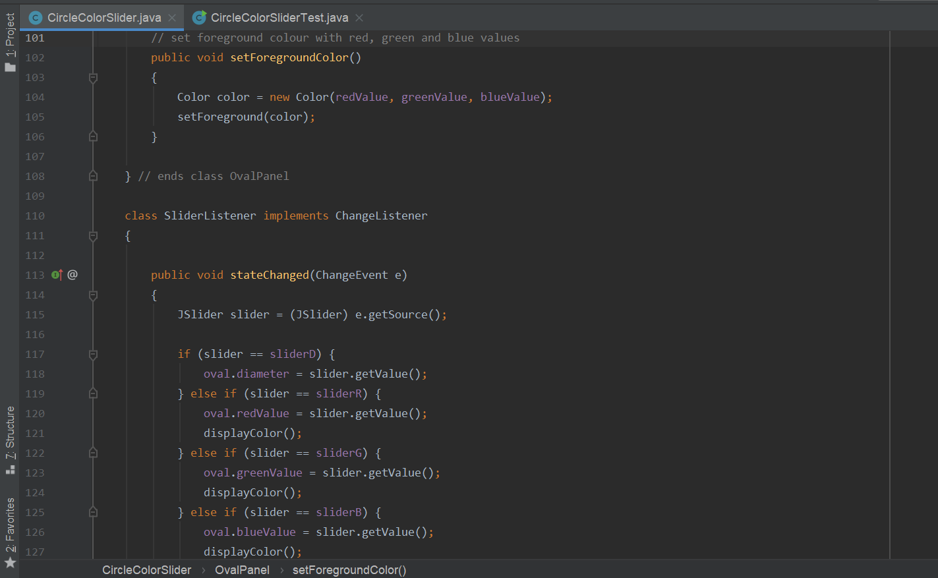

**Fig 5&6:** ChangeListener for color sliders,implemented as inner class.It handles slider events.Also has area and circumference calculated and updated alongside slider activity .

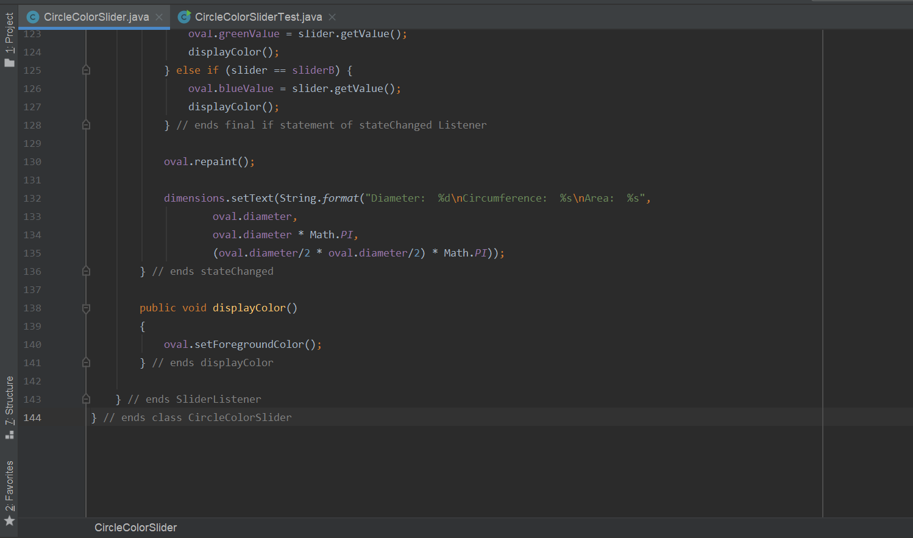

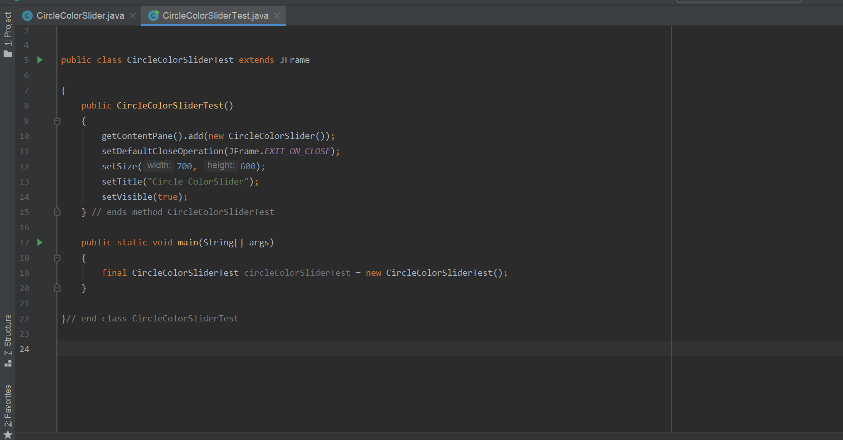

**Fig 7:**CircleColorSliderTest executes main method

**Design Problems**

Deciding the Layout to be used was an issue in the beginning. GridLayout was simple and easier to set for the contents needed for the GUI.Having Labels with the vertical sliders seemed too crowded hence took off the same.

**References**

1. Deitel & Deitel ,Java How to Program(Late Objects Version),10th edition
2. https://docs.oracle.com/javase/tutorial/uiswing/layout/grid.html.